DM LPG DISPENSER TYPE ROOF/MULTIMEDIA
The roof type dispenser is designed to be minimally affected by the weather due to roof protection. . Its simple and elegant appearance is highly preferred and widely used. With its fast and practical system, it offers high capacity filling. Ergonomically designed and maximum sealed. We can produce the machine is with single, double and four nozzles and low-height electronic panel. In production, stainless steel and electrolysis coating is resistant to weather conditions and corrosion.
We can produce the machines with different dimensions and features.
Optional mass flow meter is also available. Mass flow meters are compatible with each DM LPG Dispenser model. Can be 1-2 filling guns.
DM LPG Dispenser type Roof/Multipedia colorizes your station with the new 21.5" full HD LED (1920*1080) 1000 nits LCD Panel.

Technicality

 |  | DM-DISRM-M01 | DM-DISRM-M02 | DM-DISRM-M04
Grades |  | 1 | 1 | 1
No of nozzles |  | 1 | 2 | 4
Simultaneous fillings |  | 1 | 2 | 4
Meter Type |  | Mechanic | Mechanic | Mechanic
Capacity Max. | Lt/Min (kg/min) | 50 ( 27,5 ) | 50 ( 27,5 ) | 50 ( 27,5 )
Capacity Min. | Lt/Min (kg/min) | 5 ( 2,75 ) | 5 ( 2,75 ) | 5 ( 2,75 )
Hose (4.2 m) | INCH | 1/2" | 1/2" | 1/2"
Operating Temperature | (°C) | -25+55 | -25+55 | -25+55
Relative humidity | (%) | 100 | 100 | 100
Supply voltage | (V) | 230 | 230 | 230
Frequency | (Hz) | 50 | 50 | 50
Electronic units power | (W) | 100 | 100 | 100
Dimensions (W x L x H) | (mm) | 900 x 500 x 2000 | 900 x 500 x 2000 | 900 x 550 x 2050
Weight | (Kg) | 150 | 190 | 270
Amount/Volume programming |  | money/liter | money/liter | money/liter
Emergency stop |  | 1 | 2 | 2
Sight glass |  | NO | NO | NO
Nozzle swivel |  | YES | YES | YES
Breakaway coupling |  | 3/4" | 3/4" | 3/4"
Filter |  | YES | YES | YES
Manometer |  | YES | YES | YES
 |  | DM-DISRD-M01 | DM-DISRD-M02
Grades |  | 1 | 1
No of nozzles |  | 1 | 2
Simultaneous fillings |  | 1 | 2
Meter Type |  | Mass Flow | Mass Flow
Capacity Max. | (kg/h) | 6500 | 6500
Capacity Min. | (kg/h) | 0 | 0
Hose (4.2 m) | INCH | 1/2" | 1/2"
Operating Temperature | (°C) | -25+55 | -25+55
Relative humidity | (%) | 100 | 100
Supply voltage | (V) | 230 | 230
Frequency | (Hz) | 50 | 50
Electronic units power | (W) | 100 | 100
Dimensions (W x L x H) | (mm) | 900 x 500 x 2000 | 900 x 500 x 2000
Weight | (Kg) | 150 | 190
Amount/Volume programming |  | money/liter | money/liter
Emergency stop |  | 1 | 2
Sight glass |  | NO | NO
Nozzle swivel |  | YES | YES
Breakaway coupling |  | 3/4" | 3/4"
Filter |  | YES | YES
Manometer |  | YES | YES

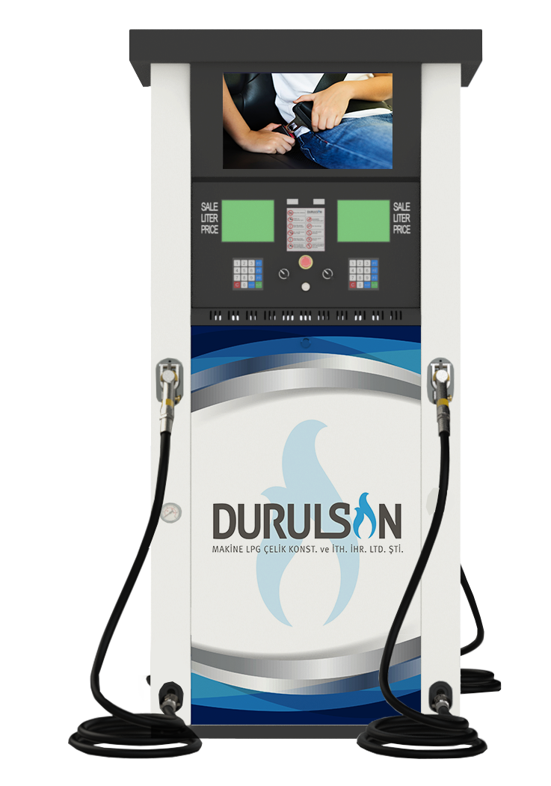

NOW, THE NEWEST DM LPG DISPENSERS
TYPE ROOF/MULTIMEDIA

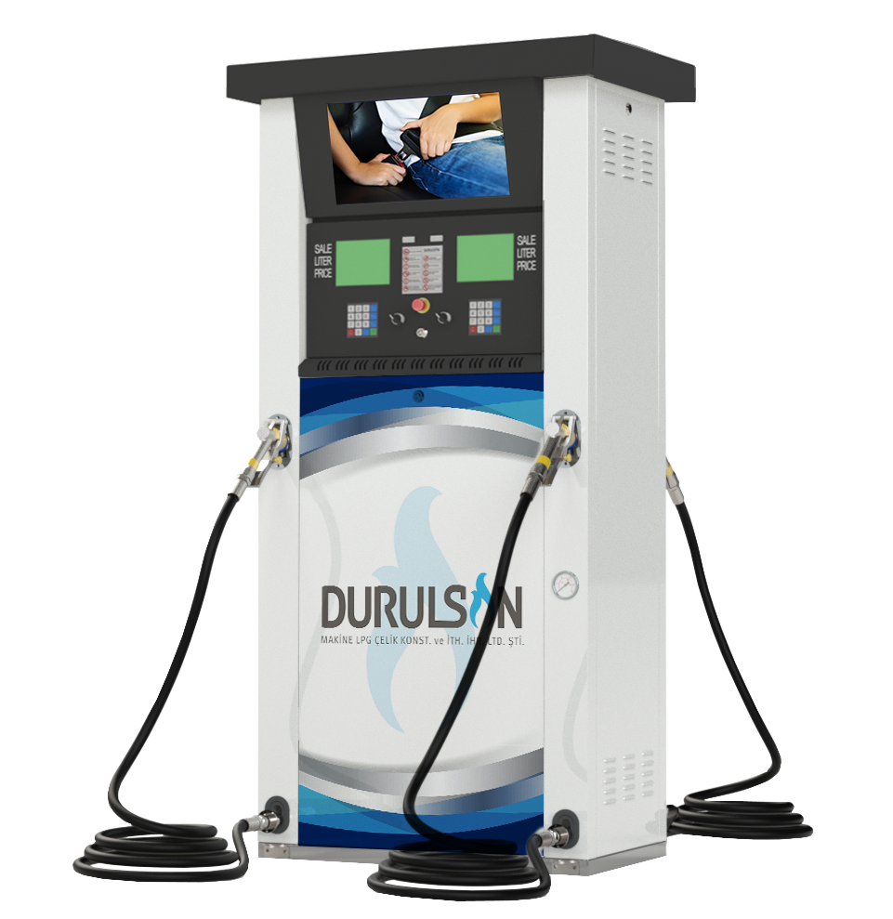

PRODUCT CODE: DM-DISRX-M04
2 Separator - 4 Meter
4 Nozzle - 4 Display – 4 Keypad

